**“ONLINE ORGANIC PRODUCTS ORDERING SYSTEM”**

**A**

**Minor Project**

**submitted in partial fulfilment for the award of**

**Bachelor of Technology in**

**Computer Science & Business Systems**

**Submitted to**

**RAJIV GANDHI PROUDYOGIKI VISHWAVIDYALAYA BHOPAL (M.P.)**



Submitted By

**Aaditya Nema – 0002CB201001. Aakash gadre – 0002CB201004.**

**Chitranjan Harode – 0002CB201022.**

**Mayank Rathore – 0002CB201032.**

Under the Guidance of professor **Vivek Sharma**

# CERTIFICATE

This is to certify that Minor Project entitled “online organic products ordering system” submitted to Rajiv Gandhi Proudyogiki Vishwavidyalaya, Bhopal (M.P.) by ________ for partial fulfilment for the award of the degree of the Bachelor of Techology in CSBS.

**Aaditya Nema – 0002CB201001.**

**Aakash gadre – 0002CB201004.**

**Chitranjan Harode – 0002CB201022.**

**Mayank Rathore – 0002CB201032.**

**APPROVAL CERTIFICATE**

This is hereby certified that the Minor Project entitled “**online organic products ordering system**” being submitted by **Aaditya Nema ( 0002CB201001),Aakash gadre ( 0002CB201004),Chitranjan Harode (0002CB201022),Mayank Rathore (0002CB201032)**to the RGPV, Bhopal is a genuine work performed by him.

Internal Examiner External Examiner

Date: Date:

ACKNOWLEDGEMENT

This is one of the best moments of my B.Tech. program to publicly acknowledgment those who have contributed in many different ways to make my success a part of their own. The completion of the Minor Project depends upon the co-operation, coordination and combined effects of several resources of knowledge energy.

I heartily thanks to **FACULTY MEMBERS NAME, who have supported in minor project**, faculties of SOIT, for accepting me to work under their Valuable Guidance, Closely Supervised this work over the past few months and offering many innovative ideas and helpful suggestions, which led to the successful completion of this dissertation work.

I am especially thankful Dr.Jitendra Agrawal Director, SOIT, Bhopal for his kind co-operation and rendering me all possible facilities.

I am thankful to all staff members of SOIT and my friends for their timely help co-operation and suggestion during my project work. Lastly but not the least, i must express thanks to my family, without their moral support it was impossible for me to complete this minor project work.

**Aaditya Nema - 0002CB201001**

**Aakash gadre - 0002CB201004**

**Chitranjan Harode -0002CB201022**

**Mayank Rathore -0002CB201032**

|  |  |
| --- | --- |
| **Table of Contents** | **Page No** |
|  |  |
|  |  |
| Chapter 1 **Introduction** | 07 |
| 1.1 Objective | 07 |
| 1.2 Scope | 08 |
| 1.3 Purpose | 08 |
| 1.4 Problem Statement | 09 |
|  |  |
| Chapter 2 **Design** | 11 |
| 2.1 E-R Diagram | 11 |
| 2.2 Data Flow Diagram | 12 |
| 2.3 Class Diagram | 13 |
| 2.4 Sequence Diagram | 14 |
| 2.5 Flow Chart Diagram, etc. | 15 |
|  |  |
| Chapter 3 **Implementation Requirements** | 16 |
| 3.1 Front-End | 16 |
| 3.2 Back-End | 19 |
|  |  |
| Chapter 4 **Lay-out** | 20 |
| 4.1 Snapshot | 20 |
| 4.2 Coding | 25 |
| 4.3 Database Tables | 61 |
|  |  |
| Chapter 5 **Application** | 62 |
| 5.1 Advantage(s) | 62 |

|  |  |
| --- | --- |
| 5.2 Disadvantage(s) | 63 |
| 5.3 Application(s) | 65 |
|  |  |
| Chapter 6 **Conclusion and Future Work** | 67 |
| 6.1 Conclusion | 67 |
| 6.2 Future Work | 68 |
|  |  |
|  |  |

# Chapter 1 Introduction

The Online Organic Products Ordering System (OOPOS) is an automated system designed to improve the ordering process of organic products from vendors. By implementing an automated system, vendors can save time and money by eliminating manual steps associated with the ordering process. It also provides customers with an easy and secure way to order organic products online. The system is composed of several components, including an online ordering system, payment gateway, inventory management system, and customer service module. The online ordering system allows customers to browse and select products, place orders, and pay for their orders. The payment gateway allows customers to securely enter their payment information and make payments. The inventory management system tracks products and keeps track of stock levels. The customer service module provides customers with assistance and answers to their questions. The system is designed to be user-friendly and easy to use. It includes features such as a search engine to easily find products, an order history to track past orders, and a virtual shopping cart to store items for future orders. It also includes advanced security measures to protect customers’ personal and financial information. Overall, the Online Organic Products Ordering System is an efficient and secure system that makes the process of ordering organic products online simple and secure.

**Objective:**

The objective of the online organic products ordering system documentation is to provide an efficient and user-friendly interface that allows customers to easily browse and purchase organic products online. The documentation should provide an overview of the system’s features, provide instructions on how to use the system, and give an overview of the technical specifications. Additionally, the documentation should enable a customer service team to provide support to customers and troubleshoot any issues that may arise.

The objective of this documentation is to provide a comprehensive overview of an online organic products ordering system. This document will outline the system's functional and non-functional requirements, user interface design, database design, system architecture, and any other necessary details for the successful development, deployment, and maintenance of the system. Additionally, this document will provide guidance on how the system should be integrated with existing systems, as well as any security considerations.

**Scope:**

The scope of this document is to provide a overview of an online organic products ordering system. It will outline the system's purpose, objectives, functions, features, requirements, and user interface. It will also include diagrams, descriptions, and diagrams to help users understand the system. Additionally, it will provide implementation steps, testing scenarios, and deployment information. Finally, this document will discuss the system's overall maintenance and support.

This document will outline the technical architecture of the system, the user interface design, the security measures to ensure data integrity and privacy, and the process for setting up and managing orders.

The system will include a user-friendly interface, an inventory management system, a payment system, and a customer relationship management (CRM) system.

The scope of this document will provide a detailed overview of the following:

* System architecture and design
* Features and benefits
* Security measures and protocols
* User interface design
* Inventory management
* Payment system • Customer relationship management
* Process for setting up and managing orders
* System testing and debugging
* System maintenance and support

**Purpose:**

The purpose of this documentation is to provide a comprehensive overview of an online organic products ordering system. This includes a detailed description of the system's features, functionalities, user interface, and implementation requirements. Additionally, the document provides a description of the system's scope and the necessary resources needed to successfully implement the system. Finally, this documentation outlines the system's purpose and how it will benefit the end user.

The scope of this document is to provide an overview of the Online Organic Products Ordering System. This document will describe the purpose, features, and functionality of the system, as well as the technical requirements and potential issues that may arise during its development and deployment. Additionally, this document will discuss the benefits of the system, including improved customer experience, increased customer loyalty, and cost savings. Finally, this document will provide a timeline for the development and deployment of the system.

**Problem statement:**

There are a number of potential issues that could arise when implementing an online organic products ordering system. Some of the most common issues include:

* Difficulty in setting up the online store and ensuring that the system is secure and reliable.
* Integration of payment processing systems with the online store.
* Difficulty in ensuring that the product information is accurate and up-to-date.
* Ensuring that customer data is secure and protected from hacking.
* Keeping track of orders and ensuring that orders are fulfilled in a timely manner.
* Ensuring that customer service is available when needed.
* Ensuring that products are delivered in a timely manner.
* Ensuring that all necessary taxes are collected and recorded correctly.
* Ensuring that the system is in compliance with relevant laws and regulations.

Overview of the challenges related to creating an online organic products ordering system. The purpose of this document is to help identify and overcome the challenges associated with developing an online ordering system for organic products.

* Create a user-friendly interface for customers to place orders online
* Manage product catalogs and pricing
* Allow customers to search for products and add them to their cart
* Develop a secure payment gateway for customers to make payments
* Generate invoices and delivery slips for customers
* Integrate the system with existing inventory management systems
* Develop a comprehensive reporting feature to track orders and analyze customer behaviour
* Design an automated system to process returns and refunds
* Develop an efficient customer service system to manage customer inquiries
* Implement a notification system to alert customers about their order status
* Develop a secure system to protect customer data from unauthorized access
* Integrate the system with social media platforms for marketing and promotion
* Identify areas for improvement and optimize the system for better performance **CHAPTER 2: DESIGN**

## E –R diagram

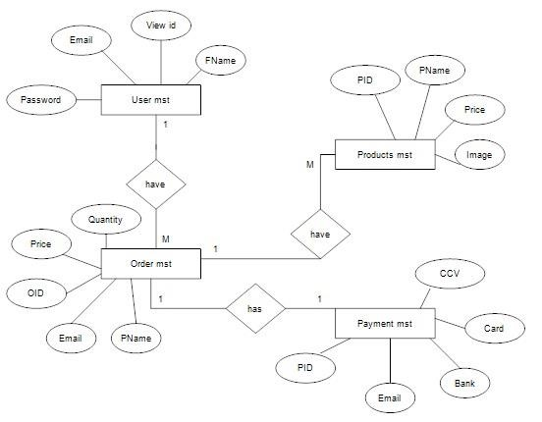

### Data Flow Diagram

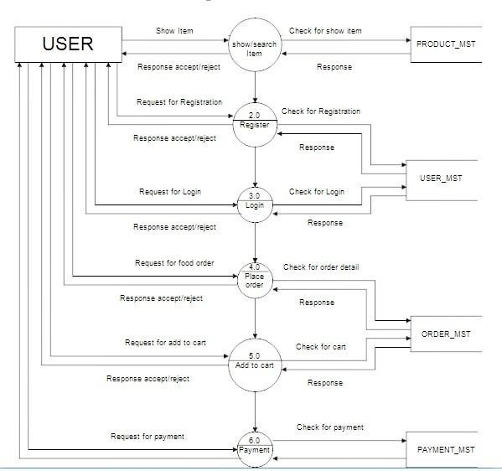

### Class Diagram

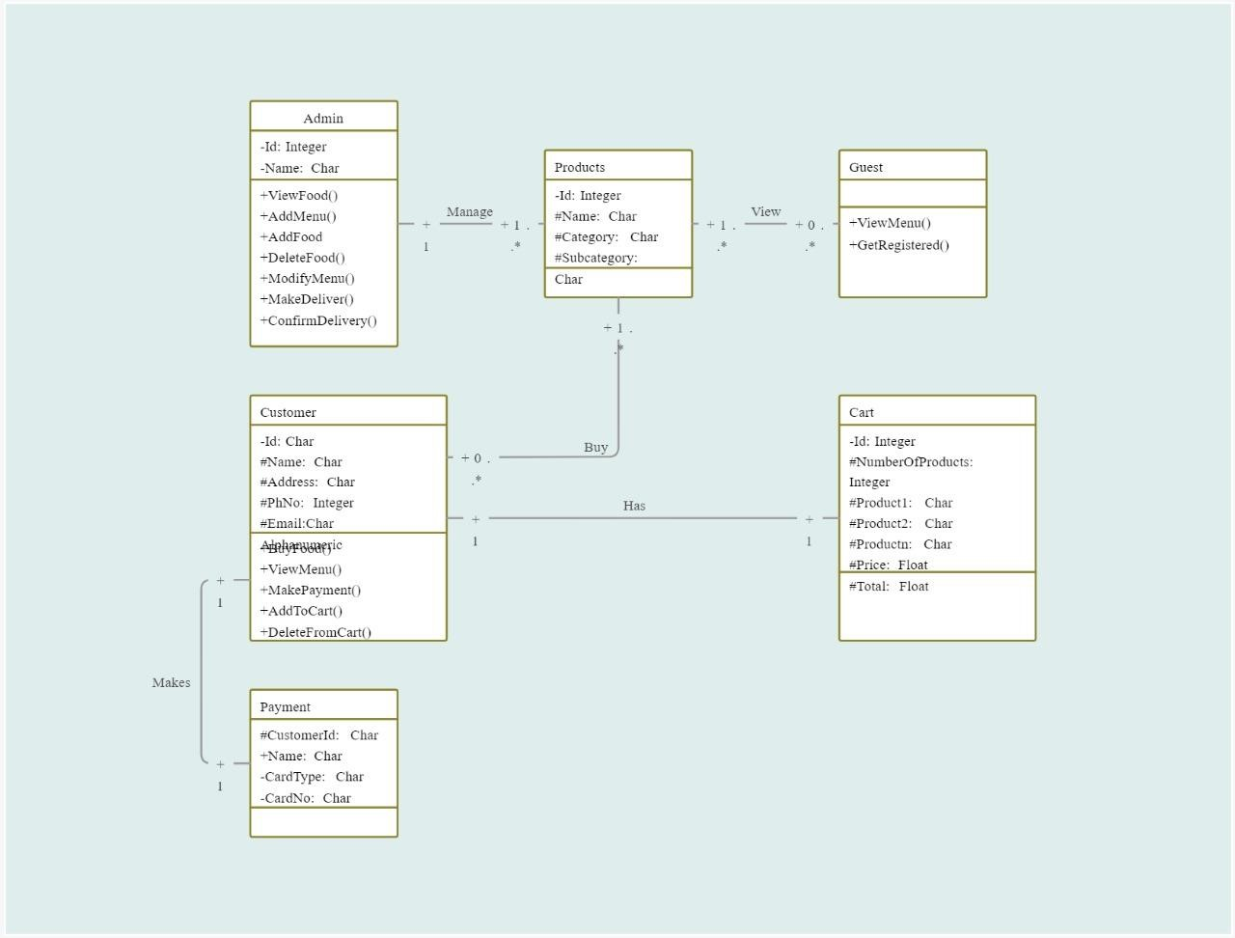

### Sequence Diagram

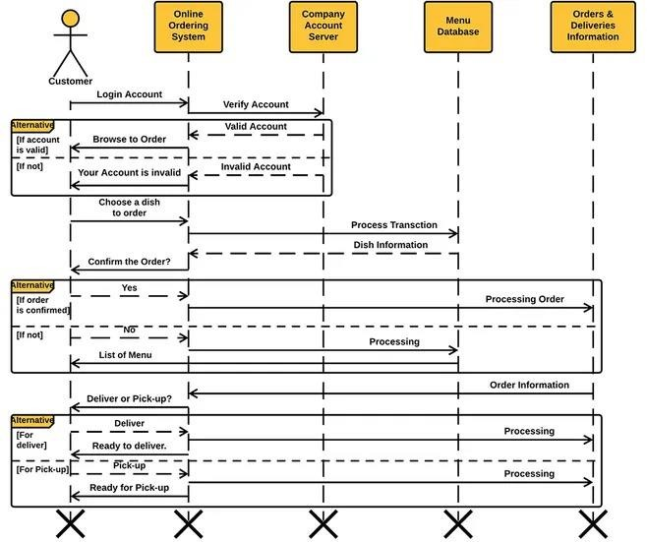

### Flow Chart Diagram

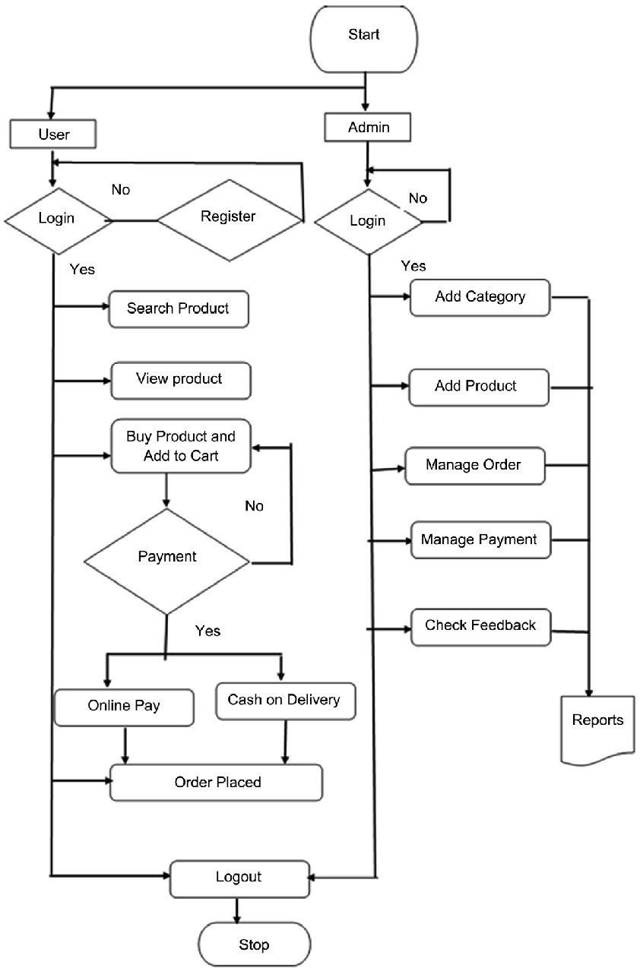

### Chapter 3 Implementation Requirements Front-End

The whole Project is divided in two parts the front end and the back end.

3.1 Front end

The front end is designed using of html ,css, Java script

HTML- HTMLorHyper Text Markup Languageis the main markuplanguage for

creating web pages and other information that can be displayed in a web browser.HTML is written in the form of HTML elements consisting of tags enclosed in angle brackets (like <html>), within the web page content. HTML tags most commonly come in pairs like <h1> and </h1>, although some tags represent empty elements and so are unpaired, for example <img>. The first tag in a pair is the start tag, and the second tag is the end tag (they are also called opening tags and closing tags). In between these tags web designers can add text, further tags, comments and other types of text-based content. The purpose of a web browser is to read HTML documents and compose them into visible or audible web pages. The browser does not display the HTML tags, but uses the tags to interpret the content of the page.HTML elements form the building blocks of all websites. HTML allows images and objects to be embedded and can be used to create interactive forms. It provides a means to create structured documents by denoting structural semantics for text such as headings, paragraphs, lists, links, quotes and other items. It can embed scripts written in languages such as JavaScript which affect the behavior of HTML web pages.

CSS- Cascading Style Sheets(CSS) is a style sheet language used fordescribing the look and formatting of a document written in a markup language. While most often used to style web pages and interfaces written in HTML and XHTML, the language can be applied to any kind of XML document, including plain XML, SVG and XUL. CSS is a cornerstone specification of the web and almost all web pages use CSS style sheets to describe their presentation.CSS is designed primarily to enable the separation of document content from document presentation, including elements such as the layout, colors, and fonts. This separation can improve content accessibility, provide more flexibility and control in the specification.

of presentation characteristics, enable multiple pages to share formatting, and reduce complexity and repetition in the structural content (such as by allowing for table less web design).CSS can also allow the same markup page to be presented in different styles for different rendering methods, such as on-screen, in print, by voice (when

14 read out by a speech-based browser or screen reader) and on Braille-based, tactile devices. It can also be used to allow the web page to display differently depending on the screen size or device on which it is being viewed. While the author of a document typically links that document to a CSS file, readers can use a different style sheet, perhaps one on their own computer, to override the one the author has specified. However if the author or the reader did not link the document to a specific style sheet the default style of the browser will be applied.CSS specifies a priority scheme to determine which style rules apply if more than one rule matches against a particular element. In this so-called cascade, priorities or weights are calculated and assigned to rules, so that the results are predictable.

### Back-End

JAVA SCRIPT- JavaScript(JS) is a dynamic computer programming language. It is

most commonly used as part of web browsers, whose implementations allow client-side scripts to interact with the user, control the browser, communicate asynchronously, and alter the document content that is displayed. It is also being used in server-side programming, game development and the creation of desktop and mobile applications. JavaScript is a prototype-based scripting language with dynamic typing and has first-class functions. Its syntax was influenced by C. JavaScript copies many names and naming conventions from Java, but the two languages are otherwise unrelated and have very different semantics. The key design principles within JavaScript are taken from

the Self and Scheme programming languages. It is a multiparadigm language, supporting objectoriented, imperative, and functional programming styles. The application of JavaScript to use outside

**RAJIV GANDHI PRODHYOGIKI VISHVAVIDHALAYA,BHOPAL**

of web pages—for example, in PDF documents, site-specific browsers, and desktop widgets—is also significant. Newer and faster JavaScript VMs and platforms built upon them (notably Node.js) have also increased the popularity of JavaScript for server-side web applications. On the client side, JavaScript was traditionally implemented as an interpreted language but just-in-time compilation is now performed by recent (post-2012) browsers.

## Chapter 4 Lay-out

### Snapshot

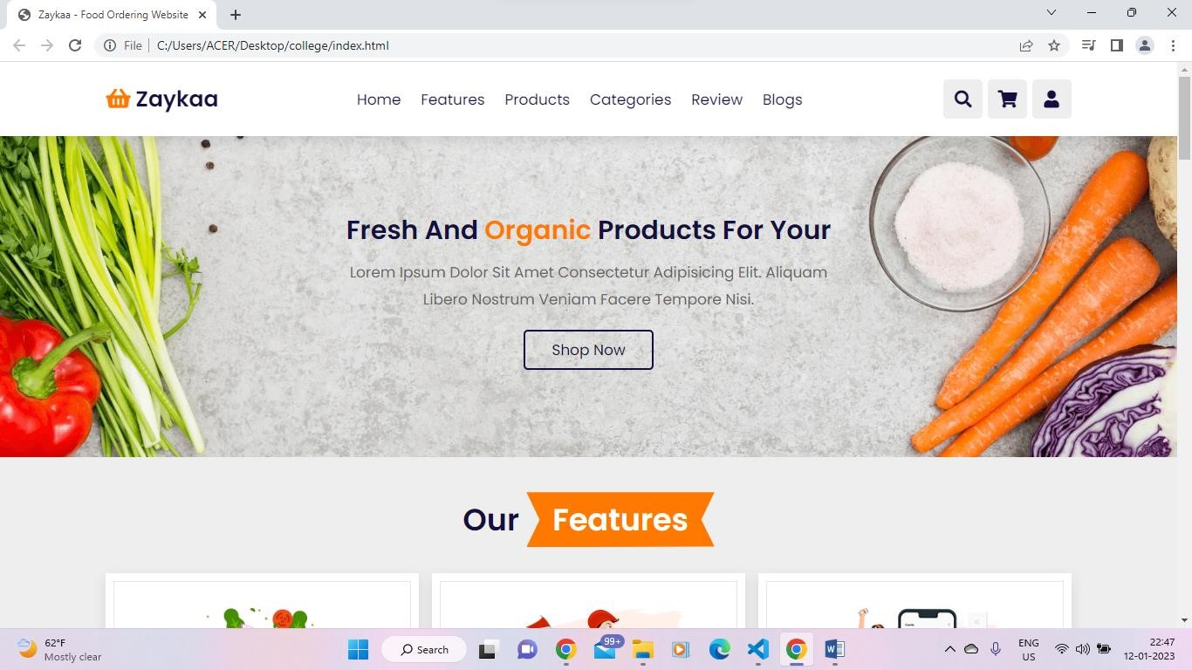

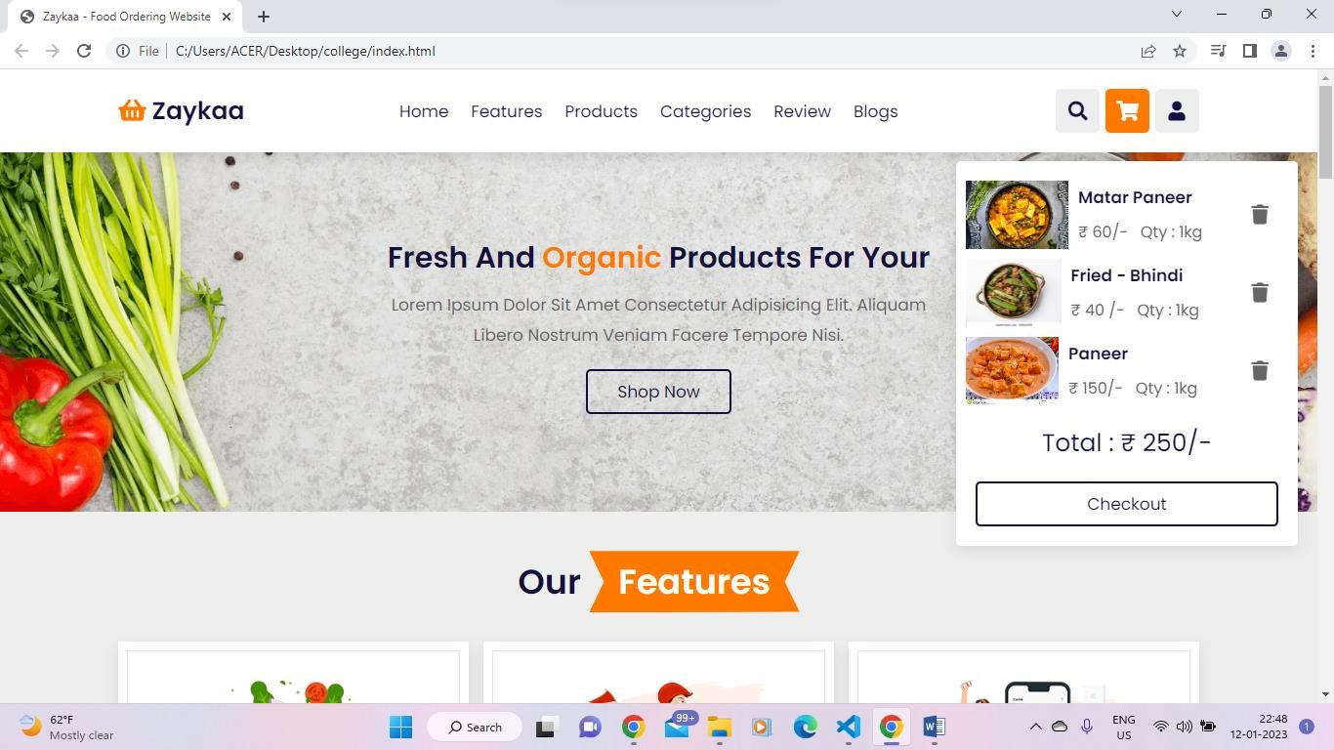

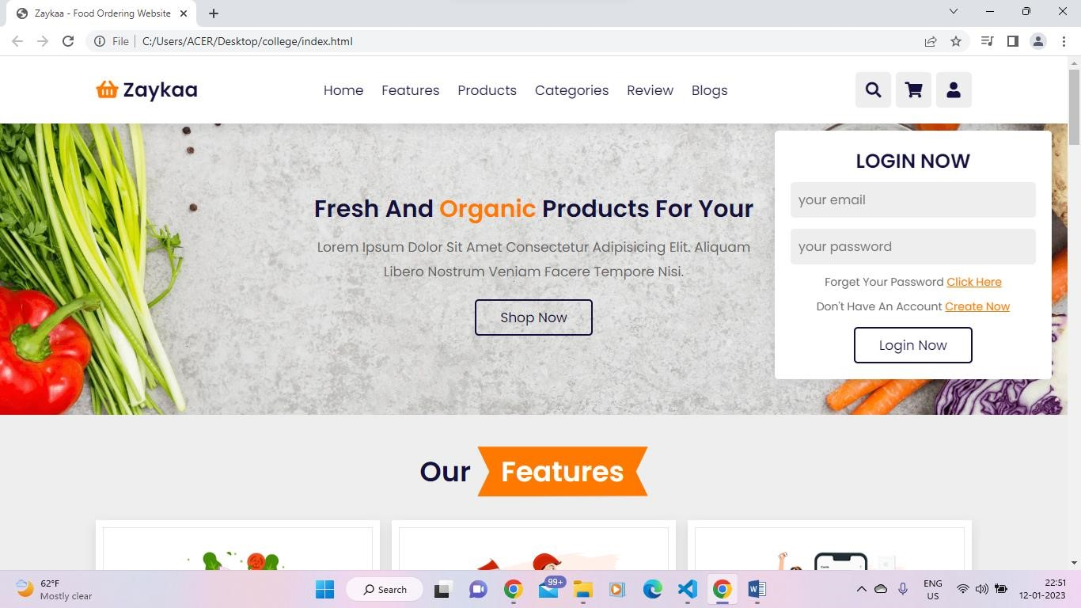

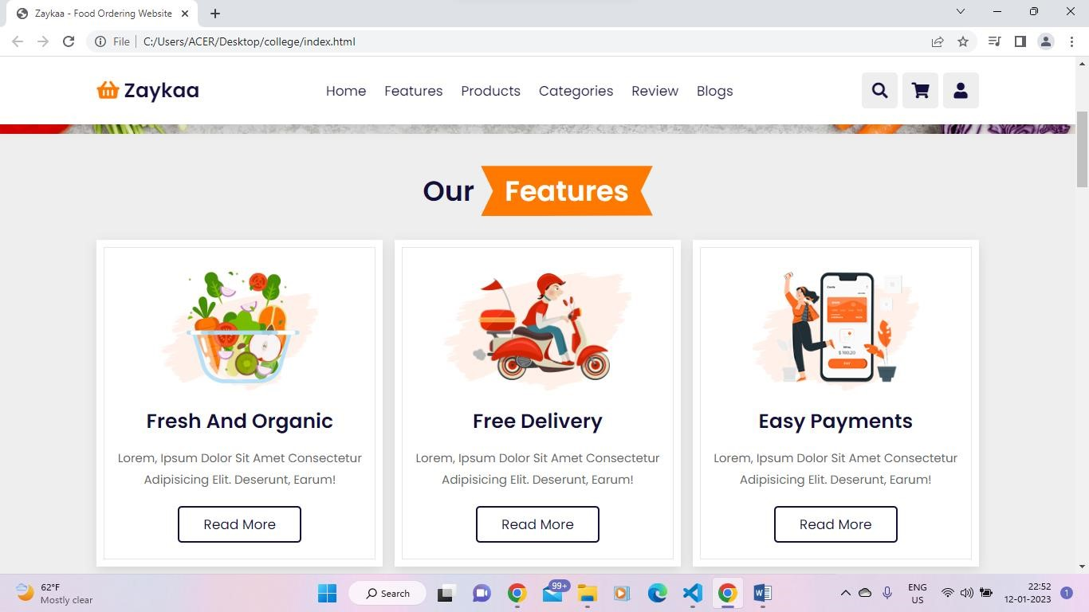

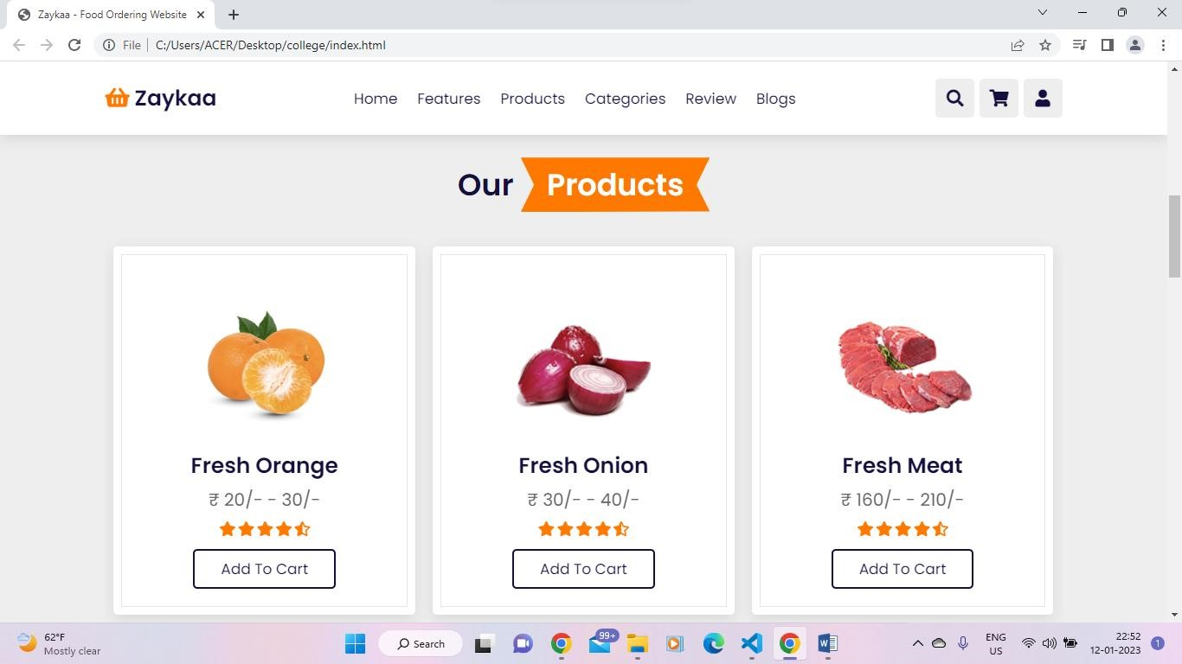

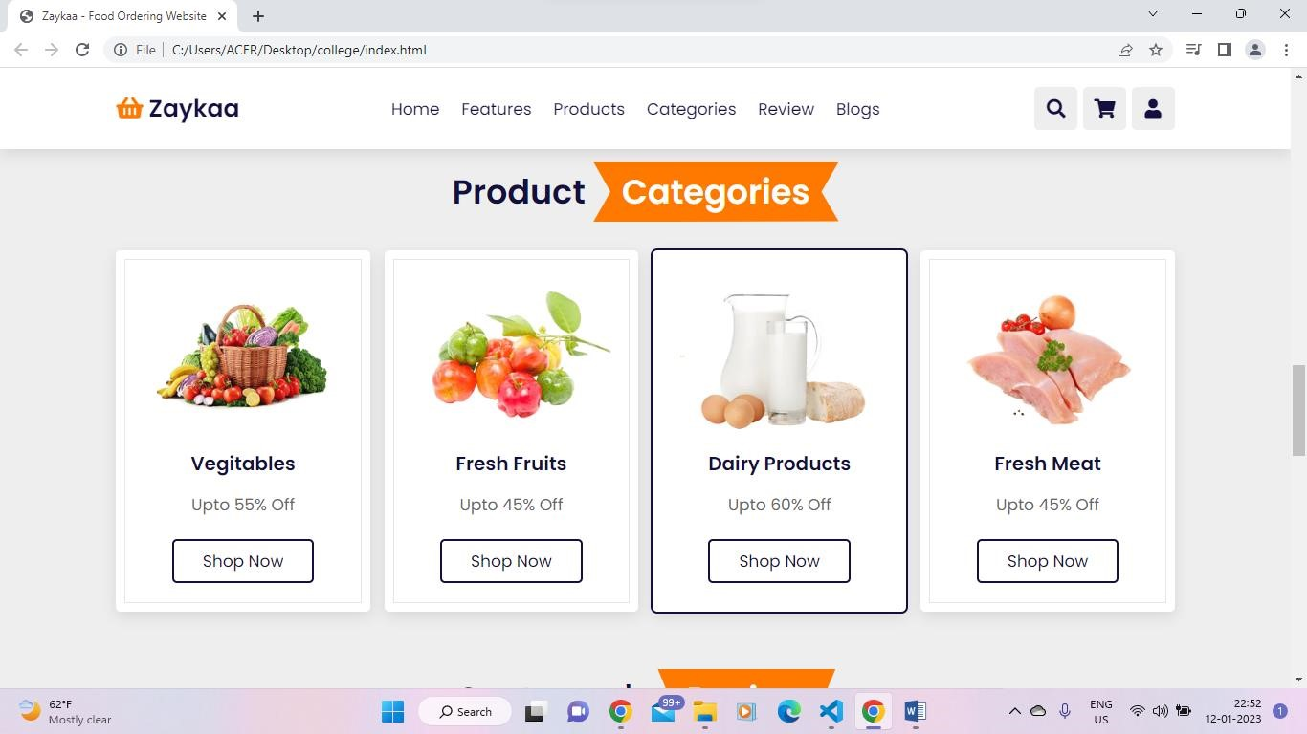

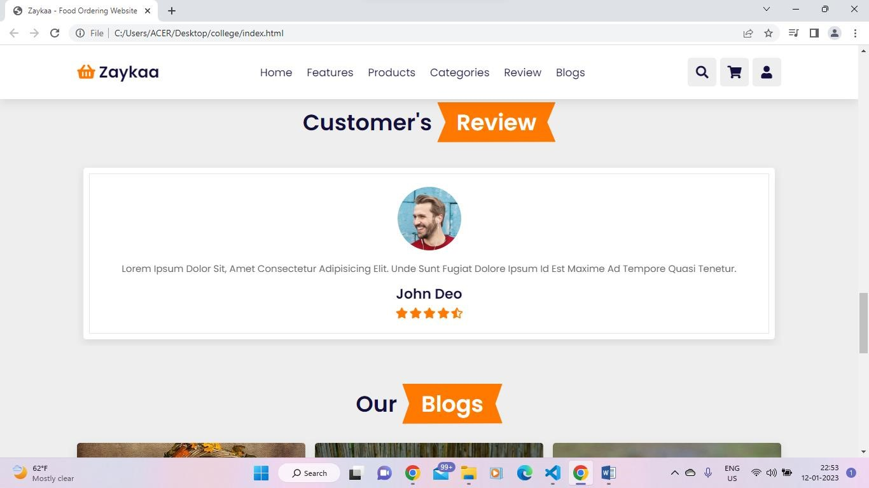

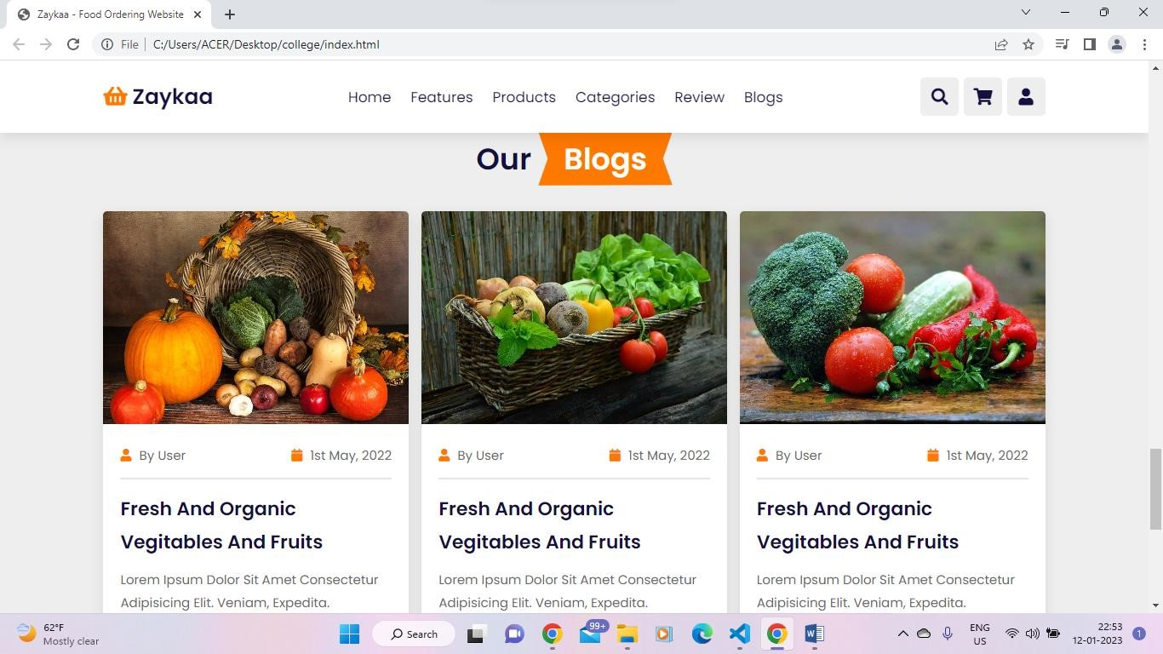

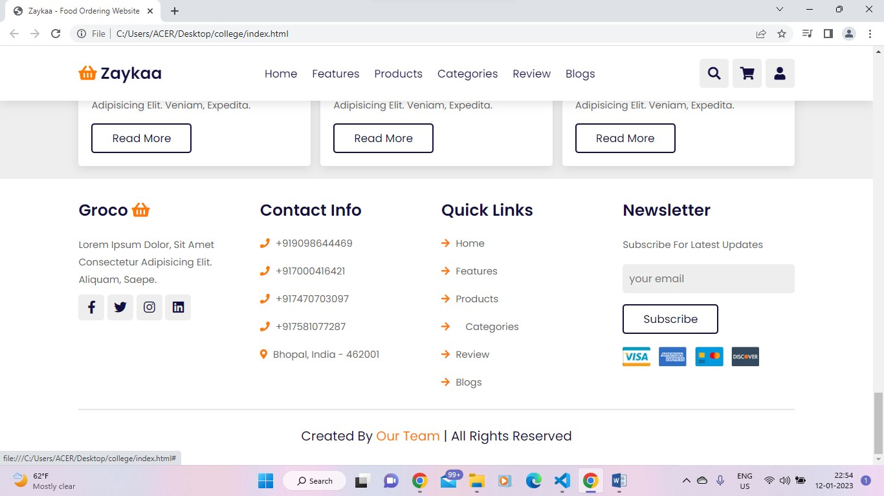

### Coding

HTML CODE

<!DOCTYPE html>

<html lang="en">

<head>

<meta charset="UTF-8">

<meta http-equiv="X-UA-Compatible" content="IE=edge">

<meta name="viewport" content="width=device-width, initial-scale=1.0">

<title>Zaykaa - Food Ordering Website</title>

<link rel="stylesheet" href="https://unpkg.com/swiper@7/swiperbundle.min.css" />

<!-- font awesome cdn link --> <link rel="stylesheet"

href="https://cdnjs.cloudflare.com/ajax/libs/fontawesome/5.15.4/css/all.min.css">

<!-- custom css file link -->

<link rel="stylesheet" href="css/style.css">

</head>

<body>

<!-- header section starts -->

<header class="header">

<a href="#" class="logo"> <i class="fas fa-shopping-basket"></i>

Zaykaa </a>

<nav class="navbar">

<a href="#home">home</a>

<a href="#features">features</a>

<a href="#products">products</a>

<a href="#categories">categories</a>

<a href="#review">review</a>

<a href="#blogs">blogs</a>

</nav>

<div class="icons">

<div class="fas fa-bars" id="menu-btn"></div>

<div class="fas fa-search" id="search-btn"></div>

<div class="fas fa-shopping-cart" id="cart-btn"></div>

<div class="fas fa-user" id="login-btn"></div>

</div>

<form action="" class="search-form">

<input type="search" id="search-box" placeholder="search here...">

<label for="search-box" class="fas fa-search"></label>

</form>

<div class="shopping-cart">

<div class="box">

<i class="fas fa-trash"></i>

<img src="img/Matar-Paneer-1.jpg" alt="">

<div class="content">

<h3>Matar paneer</h3>

<span class="price"> &#8377 60/-</span>

<span class="quantity">qty : 1kg</span>

</div>

</div>

<div class="box">

<i class="fas fa-trash"></i>

<img src="img/ladyfinger.webp" alt="">

<div class="content">

<h3> Fried - Bhindi</h3>

<span class="price"> &#8377 40 /-</span>

<span class="quantity">qty : 1kg</span>

</div>

</div>

<div class="box">

<i class="fas fa-trash"></i>

<img src="img/pneer.jpg" alt="">

<div class="content">

<h3>paneer</h3>

<span class="price"> &#8377 150/-</span>

<span class="quantity">qty : 1kg</span>

</div>

</div>

<div class="total"> total : &#8377 250/- </div>

<a href="#" class="btn">checkout</a>

</div>

<form action="" class="login-form">

<h3>login now</h3>

<input type="email" placeholder="your email" class="box">

<input type="password" placeholder="your password" class="box">

<p>forget your password <a href="#">click here</a></p>

<p>don't have an account <a href="#">create now</a></p>

<input type="submit" value="login now" class="btn">

</form>

</header>

<!-- header section ends -->

<!-- home section starts -->

<section class="home" id="home">

<div class="content">

<h3>fresh and <span>organic</span> products for your</h3> <p>Lorem ipsum dolor sit amet consectetur adipisicing elit. Aliquam libero nostrum veniam facere tempore nisi.</p>

<a href="#" class="btn">shop now</a>

</div>

</section>

<!-- home section ends -->

<!-- features section starts -->

<section class="features" id="features">

<h1 class="heading"> our <span>features</span> </h1>

<div class="box-container">

<div class="box">

<img src="image/feature-img-1.png" alt="">

<h3>fresh and organic</h3>

<p>Lorem, ipsum dolor sit amet consectetur adipisicing elit.

Deserunt, earum!</p>

<a href="#" class="btn">read more</a>

</div>

<div class="box">

<img src="image/feature-img-2.png" alt="">

<h3>free delivery</h3>

<p>Lorem, ipsum dolor sit amet consectetur adipisicing elit.

Deserunt, earum!</p>

<a href="#" class="btn">read more</a>

</div>

<div class="box">

<img src="image/feature-img-3.png" alt="">

<h3>easy payments</h3>

<p>Lorem, ipsum dolor sit amet consectetur adipisicing elit.

Deserunt, earum!</p>

<a href="#" class="btn">read more</a>

</div>

</div>

</section>

<!-- features section ends -->

<!-- products section starts -->

<section class="products" id="products">

<h1 class="heading"> our <span>products</span> </h1>

<div class="swiper product-slider">

<div class="swiper-wrapper">

<div class="swiper-slide box">

<img src="image/product-1.png" alt="">

<h3>fresh orange</h3>

<div class="price"> &#8377 20/- - 30/- </div>

<div class="stars">

<i class="fas fa-star"></i>

<i class="fas fa-star"></i>

<i class="fas fa-star"></i>

<i class="fas fa-star"></i>

<i class="fas fa-star-half-alt"></i>

</div>

<a href="#" class="btn">add to cart</a>

</div>

<div class="swiper-slide box">

<img src="image/product-2.png" alt="">

<h3>fresh onion</h3>

<div class="price"> &#8377 30/- - 40/- </div>

<div class="stars">

<i class="fas fa-star"></i>

<i class="fas fa-star"></i>

<i class="fas fa-star"></i>

<i class="fas fa-star"></i>

<i class="fas fa-star-half-alt"></i>

</div>

<a href="#" class="btn">add to cart</a>

</div>

<div class="swiper-slide box">

<img src="image/product-3.png" alt="">

<h3>fresh meat</h3>

<div class="price"> &#8377 160/- - 210/- </div>

<div class="stars">

<i class="fas fa-star"></i>

<i class="fas fa-star"></i>

<i class="fas fa-star"></i>

<i class="fas fa-star"></i>

<i class="fas fa-star-half-alt"></i>

</div>

<a href="#" class="btn">add to cart</a>

</div>

<div class="swiper-slide box">

<img src="image/product-4.png" alt="">

<h3>fresh cabbage</h3>

<div class="price"> &#8377 40/- - 50/- </div>

<div class="stars">

<i class="fas fa-star"></i>

<i class="fas fa-star"></i>

<i class="fas fa-star"></i>

<i class="fas fa-star"></i>

<i class="fas fa-star-half-alt"></i>

</div>

<a href="#" class="btn">add to cart</a>

</div>

</div>

</div>

<div class="swiper product-slider">

<div class="swiper-wrapper">

<div class="swiper-slide box">

<img src="image/product-5.png" alt="">

<h3>fresh potato</h3>

<div class="price"> &#8377 40/- - 100/- </div>

<div class="stars">

<i class="fas fa-star"></i>

<i class="fas fa-star"></i>

<i class="fas fa-star"></i>

<i class="fas fa-star"></i>

<i class="fas fa-star-half-alt"></i>

</div>

<a href="#" class="btn">add to cart</a>

</div>

<div class="swiper-slide box">

<img src="image/product-6.png" alt="">

<h3>fresh avocado</h3>

<div class="price"> &#8377 90/- - 100/- </div>

<div class="stars">

<i class="fas fa-star"></i>

<i class="fas fa-star"></i>

<i class="fas fa-star"></i>

<i class="fas fa-star"></i>

<i class="fas fa-star-half-alt"></i>

</div>

<a href="#" class="btn">add to cart</a>

</div>

<div class="swiper-slide box">

<img src="image/product-7.png" alt="">

<h3>fresh carrot</h3>

<div class="price"> &#8377 80/- - 90/- </div>

<div class="stars">

<i class="fas fa-star"></i>

<i class="fas fa-star"></i>

<i class="fas fa-star"></i>

<i class="fas fa-star"></i>

<i class="fas fa-star-half-alt"></i>

</div>

<a href="#" class="btn">add to cart</a>

</div>

<div class="swiper-slide box">

<img src="image/product-8.png" alt="">

<h3>green lemon</h3>

<div class="price"> &#8377 45/- - 55/- </div>

<div class="stars">

<i class="fas fa-star"></i>

<i class="fas fa-star"></i>

<i class="fas fa-star"></i>

<i class="fas fa-star"></i>

<i class="fas fa-star-half-alt"></i>

</div>

<a href="#" class="btn">add to cart</a> </div>

</div>

</div>

</section>

<!-- products section ends -->

<!-- categories section starts -->

<section class="categories" id="categories">

<h1 class="heading"> product <span>categories</span> </h1>

<div class="box-container">

<div class="box">

<img src="image/cat-1.png" alt="">

<h3>vegitables</h3>

<p>upto 55% off</p>

<a href="#" class="btn">shop now</a>

</div>

<div class="box">

<img src="image/cat-2.png" alt="">

<h3>fresh fruits</h3>

<p>upto 45% off</p>

<a href="#" class="btn">shop now</a>

</div>

<div class="box">

<img src="image/cat-3.png" alt="">

<h3>dairy products</h3>

<p>upto 60% off</p>

<a href="#" class="btn">shop now</a>

</div>

<div class="box">

<img src="image/cat-4.png" alt="">

<h3>fresh meat</h3>

<p>upto 45% off</p>

<a href="#" class="btn">shop now</a>

</div>

</div>

</section>

<!-- categories section ends -->

<!-- review section starts -->

<section class="review" id="review">

<h1 class="heading"> customer's <span>review</span> </h1>

<div class="swiper review-slider">

<div class="swiper-wrapper">

<div class="swiper-slide box">

<img src="image/pic-1.png" alt="">

<p>Lorem ipsum dolor sit, amet consectetur adipisicing elit. Unde sunt fugiat dolore ipsum id est maxime ad tempore quasi tenetur.</p>

<h3>john deo</h3>

<div class="stars">

<i class="fas fa-star"></i>

<i class="fas fa-star"></i>

<i class="fas fa-star"></i>

<i class="fas fa-star"></i>

<i class="fas fa-star-half-alt"></i>

</div>

</div>

</div>

</div>

</section>

<!-- review section ends -->

<!-- blogs section starts -->

<section class="blogs" id="blogs">

<h1 class="heading"> our <span>blogs</span> </h1>

<div class="box-container">

<div class="box">

<img src="image/blog-1.jpg" alt="">

<div class="content">

<div class="icons">

<a href="#"> <i class="fas fa-user"></i> by user </a> <a href="#"> <i class="fas fa-calendar"></i> 1st may,

2022 </a>

</div>

<h3>fresh and organic vegitables and fruits</h3> <p>Lorem ipsum dolor sit amet consectetur adipisicing elit. Veniam, expedita.</p>

<a href="#" class="btn">read more</a>

</div>

</div>

<div class="box">

<img src="image/blog-2.jpg" alt="">

<div class="content">

<div class="icons">

<a href="#"> <i class="fas fa-user"></i> by user </a> <a href="#"> <i class="fas fa-calendar"></i> 1st may,

2022 </a>

</div>

<h3>fresh and organic vegitables and fruits</h3> <p>Lorem ipsum dolor sit amet consectetur adipisicing elit. Veniam, expedita.</p>

<a href="#" class="btn">read more</a>

</div>

</div>

<div class="box">

<img src="image/blog-3.jpg" alt="">

<div class="content">

<div class="icons">

<a href="#"> <i class="fas fa-user"></i> by user </a> <a href="#"> <i class="fas fa-calendar"></i> 1st may,

2022 </a>

</div>

<h3>fresh and organic vegitables and fruits</h3> <p>Lorem ipsum dolor sit amet consectetur adipisicing elit. Veniam, expedita.</p>

<a href="#" class="btn">read more</a>

</div>

</div>

</div>

</section>

<!-- blogs section ends -->

<!-- footer section starts -->

<section class="footer">

<div class="box-container">

<div class="box">

<h3> groco <i class="fas fa-shopping-basket"></i> </h3> <p>Lorem ipsum dolor, sit amet consectetur adipisicing elit.

Aliquam, saepe.</p>

<div class="share">

<a target="_blank" href="#" class="fab fa-facebook-f">

</a>

<a href="#" class="fab fa-twitter"></a>

<a href="#" class="fab fa-instagram"></a>

<a href="#" class="fab fa-linkedin"></a>

</div>

</div>

<div class="box">

<h3>contact info</h3>

<a href="#" class="links"> <i class="fas fa-phone"></i> +919098644469 </a>

<a href="#" class="links"> <i class="fas fa-phone"></i> +917000416421 </a>

<a href="#" class="links"> <i class="fas fa-phone"></i> +917470703097 </a>

<a href="#" class="links"> <i class="fas fa-phone"></i>

+917581077287 </a>

<!-- <a href="#" class="links"> <i class="fas faenvelope"></i> @gmail.com </a> -->

<a href="#" class="links"> <i class="fas fa-map-markeralt"></i> Bhopal, india - 462001 </a>

</div>

<div class="box">

<h3>quick links</h3>

<a href="#" class="links"> <i class="fas fa-arrow-right"></i> home </a>

<a href="#" class="links"> <i class="fas fa-arrow-right"></i> features </a>

<a href="#" class="links"> <i class="fas fa-arrow-right"></i> products </a>

<a href="#" class="links"> <i class="fas fa-arrow-right"></i> categories </a>

<a href="#" class="links"> <i class="fas fa-arrow-right"></i> review </a>

<a href="#" class="links"> <i class="fas fa-arrow-right"></i> blogs </a>

</div>

<div class="box">

<h3>newsletter</h3>

<p>subscribe for latest updates</p>

<input type="email" placeholder="your email" class="email">

<input type="submit" value="subscribe" class="btn">

<img src="image/payment.png" class="payment-img" alt="">

</div>

</div>

<div class="credit"> created by <span> our team</span> | all rights reserved </div>

</section>

<!-- footer section ends -->

<script src="https://unpkg.com/swiper@7/swiper-bundle.min.js"></script>

<!-- custom js file link -->

<script src="js/script.js"></script>

</body>

</html>

#### CSS CODE

@import

url('https://fonts.googleapis.com/css2?family=Poppins:wght@100;300;400;500

;600&display=swap');

:root{

--orange:#ff7800;

--black:#130f40;

--light-color:#666;

--box-shadow:0 .5rem 1.5rem rgba(0,0,0,.1);

--border:.2rem solid rgba(0,0,0,.1);

--outline:.1rem solid rgba(0,0,0,.1);

--outline-hover:.2rem solid var(--black);

}

*{

font-family: 'Poppins', sans-serif; margin:0; padding:0;

box-sizing: border-box; outline: none; border:none; text-decoration: none; text-transform: capitalize; transition: all .2s linear;

} html{ font-size: 62.5%; overflow-x: hidden; scroll-behavior: smooth; scroll-padding-top: 7rem;

} body{ background:#eee;

} section{

padding:2rem 9%;

}

.heading{

text-align: center; padding:2rem 0; padding-bottom: 3rem; font-size: 3.5rem; color:var(--black);

}

.heading span{

background: var(--orange); color:#fff; display: inline-block;

padding:.5rem 3rem; clip-path: polygon(100% 0, 93% 50%, 100% 99%, 0% 100%, 7% 50%, 0% 0%); }

.btn{ margin-top: 1rem; display: inline-block; padding:.8rem 3rem; font-size: 1.7rem; border-radius: .5rem; border:.2rem solid var(--black); color:var(--black); cursor: pointer; background: none;

}

.btn:hover{ background: var(--orange); color:#fff;

}

.header{ position: fixed; top:0; left:0; right: 0; z-index: 1000; display: flex; align-items: center; justify-content: space-between; padding:2rem 9%; background:#fff; box-shadow: var(--box-shadow);

}

.header .logo{ font-size: 2.5rem; font-weight: bolder; color:var(--black);

}

.header .logo i{ color:var(--orange);

}

.header .navbar a{ font-size: 1.7rem; margin:0 1rem; color:var(--black);

}

.header .navbar a:hover{ color:var(--orange);

}

.header .icons div{ height: 4.5rem; width: 4.5rem; line-height: 4.5rem; border-radius: .5rem; background: #eee; color:var(--black); font-size: 2rem; margin-left: .3rem; cursor: pointer; text-align: center;

}

.header .icons div:hover{ background: var(--orange); color:#fff;

}

#menu-btn{ display: none;

}

.header .search-form{ position: absolute; top:110%; right:-110%; width: 50rem; height:5rem; background: #fff; border-radius: .5rem; overflow: hidden; display: flex; align-items: center; box-shadow: var(--box-shadow);

}

.header .search-form.active{ right:2rem; transition: .4s linear;

}

.header .search-form input{ height:100%; width:100%; background: none; text-transform: none; font-size: 1.6rem; color:var(--black); padding:0 1.5rem;

}

.header .search-form label{ font-size: 2.2rem; padding-right: 1.5rem; color:var(--black); cursor: pointer;

}

.header .search-form label:hover{ color:var(--orange);

}

.header .shopping-cart{ position: absolute; top:110%; right:-110%; padding:1rem; border-radius: .5rem; box-shadow: var(--box-shadow); width:35rem; background: #fff;

}

.header .shopping-cart.active{ right:2rem; transition: .4s linear;

}

.header .shopping-cart .box{ display: flex; align-items: center; gap:1rem; position: relative; margin:1rem 0;

}

.header .shopping-cart .box img{ height:7rem;

}

.header .shopping-cart .box .fa-trash{ font-size: 2rem; position: absolute; top:50%; right:2rem; cursor: pointer; color:var(--light-color); transform: translateY(-50%);

}

.header .shopping-cart .box .fa-trash:hover{ color:var(--orange);

}

.header .shopping-cart .box .content h3{ color:var(--black); font-size: 1.7rem; padding-bottom: 1rem;

}

.header .shopping-cart .box .content span{ color:var(--light-color); font-size: 1.6rem;

}

.header .shopping-cart .box .content .quantity{ padding-left: 1rem;

}

.header .shopping-cart .total{ font-size: 2.5rem; padding:1rem 0; text-align: center; color:var(--black);

}

.header .shopping-cart .btn{ display: block; text-align: center; margin:1rem;

}

.header .login-form{ position: absolute; top:110%; right:-110%; width:35rem; box-shadow: var(--box-shadow); padding:2rem; border-radius: .5rem; background: #fff; text-align: center;

}

.header .login-form.active{ right:2rem; transition: .4s linear;

}

.header .login-form h3{ font-size: 2.5rem; text-transform: uppercase; color: var(--black);

}

.header .login-form .box{ width: 100%; margin:.7rem 0; background:#eee; border-radius: .5rem; padding:1rem; font-size: 1.6rem; color:var(--black); text-transform: none;

}

.header .login-form p{ font-size: 1.4rem; padding:.5rem 0; color:var(--light-color);

}

.header .login-form p a{ color:var(--orange); text-decoration: underline;

}

.home{ display: flex; align-items: center; justify-content: center; background: url(../image/banner-bg.webp) no-repeat; background-position: center; background-size: cover; padding-top: 17rem; padding-bottom: 10rem;

}

.home .content{ text-align: center; width:60rem;

}

.home .content h3{ color:var(--black); font-size: 3rem;

}

.home .content h3 span{ color:var(--orange);

}

.home .content p{ color:var(--light-color); font-size: 1.7rem; padding:1rem 0; line-height: 1.8;

}

.features .box-container{ display: grid; grid-template-columns: repeat(auto-fit, minmax(30rem, 1fr)); gap:1.5rem;

}

.features .box-container .box{ padding:3rem 2rem; background: #fff; outline: var(--outline); outline-offset: -1rem; text-align: center; box-shadow: var(--box-shadow);

}

.features .box-container .box:hover{ outline: var(--outline-hover); outline-offset: 0rem;

}

.features .box-container .box img{ margin:1rem 0; height: 15rem;

}

.features .box-container .box h3{ font-size: 2.5rem; line-height: 1.8; color:var(--black);

}

.features .box-container .box p{

font-size: 1.5rem; line-height: 1.8; color:var(--light-color); padding:1rem 0;

}

.products .product-slider{ padding:1rem;

}

.products .product-slider:first-child{ margin-bottom: 2rem;

}

.products .product-slider .box{ background: #fff; border-radius: .5rem; text-align: center; padding:3rem 2rem; outline-offset: -1rem; outline: var(--outline); box-shadow: var(--box-shadow); transition: .2s linear;

}

.products .product-slider .box:hover{ outline-offset: 0rem; outline: var(--outline-hover);

}

.products .product-slider .box img{ height:20rem;

}

.products .product-slider .box h3{ font-size: 2.5rem; color:var(--black);

}

.products .product-slider .box .price{ font-size: 2rem; color:var(--light-color); padding:.5rem 0;

}

.products .product-slider .box .stars i{ font-size: 1.7rem; color:var(--orange); padding:.5rem 0;

}

.categories .box-container{ display: grid; grid-template-columns: repeat(auto-fit, minmax(26rem, 1fr)); gap:1.5rem;

}

.categories .box-container .box{ padding:3rem 2rem; border-radius: .5rem; background:#fff; box-shadow: var(--box-shadow); outline:var(--outline); outline-offset: -1rem; text-align: center;

}

.categories .box-container .box:hover{ outline:var(--outline-hover); outline-offset: 0rem;

}

.categories .box-container .box img{ margin:1rem 0; height:15rem;

}

.categories .box-container .box h3{ font-size: 2rem; color:var(--black); line-height: 1.8;

}

.categories .box-container .box p{ font-size: 1.7rem; color:var(--light-color); line-height: 1.8; padding:1rem 0;

}

.review .review-slider{ padding:1rem;

}

.review .review-slider .box{ background: #fff; border-radius: .5rem; text-align: center; padding:3rem 2rem; outline-offset: -1rem; outline: var(--outline); box-shadow: var(--box-shadow); transition: .2s linear;

}

.review .review-slider .box:hover{ outline:var(--outline-hover);

outline-offset: 0rem;

}

.review .review-slider .box img{ height:10rem; width:10rem; border-radius: 50%;

}

.review .review-slider .box p{ padding:1rem 0; line-height: 1.8; color:var(--light-color); font-size: 1.5rem;

}

.review .review-slider .box h3{ padding-bottom: .5rem; color:var(--black); font-size: 2.2rem;

}

.review .review-slider .box .stars i{ color:var(--orange); font-size: 1.7rem;

}

.blogs .box-container{ display: grid; grid-template-columns: repeat(auto-fit, minmax(30rem, 1fr)); gap:1.5rem;

}

.blogs .box-container .box{ overflow: hidden; border-radius: .5rem;

box-shadow: var(--box-shadow);

background:#fff;

}

.blogs .box-container .box img{ height:25rem; width:100%; object-fit: cover;

}

.blogs .box-container .box .content{ padding:2rem;

}

.blogs .box-container .box .content .icons{ display: flex; align-items: center; justify-content: space-between; padding-bottom: 1.5rem; margin-bottom: 1rem; border-bottom: var(--border);

}

.blogs .box-container .box .content .icons a{ color:var(--light-color); font-size: 1.5rem;

}

.blogs .box-container .box .content .icons a:hover{ color:var(--black);

}

.blogs .box-container .box .content .icons a i{ color:var(--orange); padding-right: .5rem;

}

.blogs .box-container .box .content h3{ line-height: 1.8; color:var(--black); font-size: 2.2rem; padding:.5rem 0;

}

.blogs .box-container .box .content p{ line-height: 1.8; color:var(--light-color); font-size: 1.5rem; padding:.5rem 0;

}

.footer{

background: #fff;

}

.footer .box-container{ display: grid; grid-template-columns: repeat(auto-fit, minmax(25rem, 1fr)); gap:1.5rem;

}

.footer .box-container .box h3{ font-size: 2.5rem; color:var(--black); padding:1rem 0;

}

.footer .box-container .box h3 i{ color:var(--orange);

}

.footer .box-container .box .links{ display: block;

font-size: 1.5rem; color:var(--light-color); padding:1rem 0;

}

.footer .box-container .box .links i{ color:var(--orange); padding-right: .5rem;

}

.footer .box-container .box .links:hover i{ padding-right: 2rem;

}

.footer .box-container .box p{ line-height: 1.8; font-size: 1.5rem; color:var(--light-color); padding:1rem 0;

}

.footer .box-container .box .share a{ height:4rem; width:4rem; line-height:4rem; border-radius: .5rem; font-size: 2rem; color:var(--black); margin-right: .2rem; background: #eee; text-align: center;

}

.footer .box-container .box .share a:hover{ background: var(--orange);

color: #fff;

}

.footer .box-container .box .email{ width: 100%; margin:.7rem 0; padding:1rem; border-radius: .5rem; background: #eee; font-size: 1.6rem; color:var(--black); text-transform: none;

}

.footer .box-container .box .payment-img{ margin-top: 2rem; height: 3rem; display: block;

}

.footer .credit{ text-align: center; margin-top: 2rem; padding:1rem; padding-top: 2.5rem; font-size: 2rem; color:var(--black); border-top: var(--border);

}

.footer .credit span{ color:var(--orange);

}

/* media queries */

@media (max-width:991px){

html{ font-size: 55%;

}

.header{ padding:2rem;

} section{ padding:2rem;

}

}

@media (max-width:768px){

#menu-btn{ display: inline-block;

}

.header .search-form{ width:90%;

}

.header .navbar{ position: absolute; top:110%; right:-110%; width:30rem; box-shadow: var(--box-shadow); border-radius: .5rem; background: #fff;

}

.header .navbar.active{ right:2rem; transition: .4s linear;

}

.header .navbar a{ font-size: 2rem; margin:2rem 2.5rem; display: block;

}

}

@media (max-width:450px){

html{ font-size: 50%;

}

.heading{ font-size: 2.5rem;

}

.footer{ text-align: center;

}

.footer .box-container .box .payment-img{ margin: 2rem auto;

}

}

**JS CODE**

let searchForm = document.querySelector('.search-form');

document.querySelector('#search-btn').onclick = () =>{ searchForm.classList.toggle('active'); shoppingCart.classList.remove('active'); loginForm.classList.remove('active'); navbar.classList.remove('active');

}

let shoppingCart = document.querySelector('.shopping-cart');

document.querySelector('#cart-btn').onclick = () =>{ shoppingCart.classList.toggle('active'); searchForm.classList.remove('active'); loginForm.classList.remove('active'); navbar.classList.remove('active');

}

let loginForm = document.querySelector('.login-form');

document.querySelector('#login-btn').onclick = () =>{ loginForm.classList.toggle('active'); searchForm.classList.remove('active'); shoppingCart.classList.remove('active'); navbar.classList.remove('active');

}

let navbar = document.querySelector('.navbar');

document.querySelector('#menu-btn').onclick = () =>{ navbar.classList.toggle('active'); searchForm.classList.remove('active'); shoppingCart.classList.remove('active'); loginForm.classList.remove('active');

}

var swiper = new Swiper(".product-slider", { loop:true, spaceBetween: 20, autoplay: { delay: 7500, disableOnInteraction: false,

}, centeredSlides: true, breakpoints: { 0: { slidesPerView: 1,

}, 768: { slidesPerView: 2,

}, 1020: { slidesPerView: 3,

},

},

});

### Database Tables

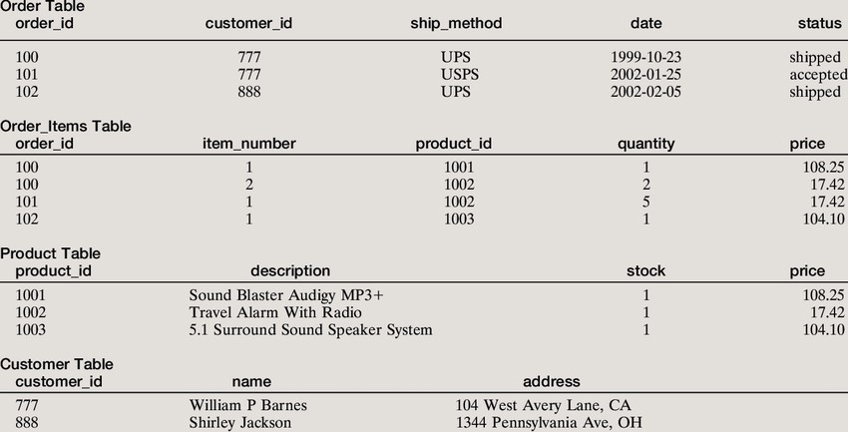

## Chapter 5 Application

**Advantage(s)**

Advantages of online organic product ordering systems:

1. Ease of use: Online organic product ordering systems are easy to use and can be accessed from anywhere with an internet connection. This makes it easier to order organic products without having to physically go to a store.

1. Increased convenience: Online organic product ordering systems provide customers with more convenience since they do not have to wait in line or drive to a store. Customers can place orders anytime and anywhere.

1. Improved customer service: Online organic product ordering systems provide customers with better customer service since they can easily track their orders and receive updates on their purchases.

1. Increased reach: Online organic product ordering systems allow customers to access a wider range of products from different stores. This helps customers find the best product for their needs.

1. Cost savings: Online organic product ordering systems can help customers save money since they do not have to pay for the cost of transportation or wait in line.

6). Improved Customer Service: An online organic product ordering system can provide customers with better service by allowing them to place orders quickly and easily. Customers can use the system to view product availability, compare prices, and place orders without having to contact customer service representatives.

7). Increased Efficiency: An online organic product ordering system can help streamline operations by eliminating manual processes such as order taking and fulfillment. This can help reduce costs and increase profitability.

8). Increased Visibility: An online organic product ordering system provides visibility into product availability, stock levels, and customer orders. This can help businesses better manage inventory and ensure that products are in stock when customers need them.

9). Improved Accessibility: An online organic product ordering system can make products more accessible to customers by allowing them to place orders from any device, at any time. This can help businesses maximize sales and reach new customers.

10). Increased Security: An online organic product ordering system can provide increased security and protect businesses from fraudulent orders. The system can also help protect customers’ data and ensure that their information is kept secure.

### Disadvantage(s)

Disadvantages of online organic product ordering systems:

1). High Cost of Implementing and Maintaining: Developing and maintaining an online organic product ordering system can be expensive. The cost of hardware and software needed to create and maintain the system can be high.

2). Security Concerns: Online organic product ordering systems are vulnerable to cyber-attacks and data breaches. Even with multiple levels of security in place, malicious hackers can still find a way to gain access to the system and steal customer data.

3). User Interface Issues: The user interface of an online organic product ordering system needs to be easy to understand and navigate. Poor user interface design can lead to a poor customer experience and result in fewer customers using the system.

4). Difficulty in setting up the system: Setting up an online organic product ordering system can be quite difficult and time consuming. It requires a lot of technical knowledge and expertise to configure the system correctly.

5). Expensive to maintain: Online organic product ordering systems require regular maintenance and updates in order to remain secure and functional. This can be expensive, and unless you are able to do the maintenance yourself, you will have to pay someone else to do it for you.

6). Complex user interface: An online organic product ordering system can be quite complex, with lots of features and settings. This can be difficult for some users to navigate, especially if they are not tech-savvy.

7). Lack of support: Depending on the vendor, you may not be able to get any support if you experience any technical difficulties. This can make it difficult to solve any problems you may encounter.

### Application(s)

name: Online organic product ordering system

Objective: The objective of the Online Organic Product Ordering System is to allow customers to order organic products online.

Features:

* Easy and secure payment options: The system will provide secure payment options like PayPal, credit card, and Apple/Google Pay for customers to make their payments conveniently.

* Product search: Customers can search for organic products by entering relevant keywords.

* Product catalog: Customers can browse a catalog of organic products and select the products they want to order.

* Order tracking: Customers can track their orders from the time the order is placed till it is delivered.

* Order history: Customers can view their past orders and check the history of their purchases.

* Reviews and ratings: Customers can review and rate the products they have ordered.

#### RAJIV GANDHI PRODHYOGIKI VISHVAVIDHALAYA,BHOPAL

* Loyalty program: Customers can join a loyalty program and get discounts on their purchases.

* Customer support: Customers can contact customer support in case of any queries or issues.

* Social media integration: Customers can use their social media accounts to log in and order products.

* Push notifications: Customers can receive notifications about latest offers and discounts.

* Mobile app: Customers can

**RAJIV GANDHI PRODHYOGIKI VISHVAVIDHALAYA,BHOPAL**

## Chapter 6 Conclusion and Future Work

### Conclusion

In conclusion, the online organic product ordering system is a valuable tool for businesses and customers alike. It provides a secure and efficient way for customers to purchase organic products online. The system also allows businesses to manage their inventory, process orders, and maintain customer relationships. The system is designed to be user-friendly and intuitive, making it easy to use. Additionally, the system has a number of features that can be customized to suit different businesses needs. With its advanced features and secure payment processing, the online organic product ordering system is an ideal solution for businesses looking to increase their customer base and online presence.

The conclusion of this document is that an online organic product ordering system can be an effective way for businesses to increase sales and customer satisfaction. It provides an easy, efficient, and secure ordering process for customers, as well as access to a variety of organic products. With its many advantages, an online organic product ordering system can be a powerful tool for businesses to increase their reach and revenue

**RAJIV GANDHI PRODHYOGIKI VISHVAVIDHALAYA,BHOPAL**

### Future Work

Future work on an online organic product ordering system could include:

1. Improving the user interface and user experience of the system.

1. Developing an app to make it even more convenient for users to order their organic products.

1. Integrating the system with payment gateways to allow for secure and efficient payment solutions.

1. Introducing new features such as product recommendations and personalized product selections.

1. Improving the system’s ability to handle large orders and orders from multiple vendors.

1. Improving the system’s search capabilities, to make it easier for customers to find what they’re looking for.

1. Enhancing the overall security of the system, to protect customers’ personal and financial information.

1. Adding loyalty rewards and other incentives for customers to keep coming back.

#### SCHOOL OF INFORMATION TECHNOLOGY

**RAJIV GANDHI PRODHYOGIKI VISHVAVIDHALAYA,BHOPAL**

9. Integrating the system with social media to enable customers to share their experiences and recommendations with friends and family.